Place Aerial Cable

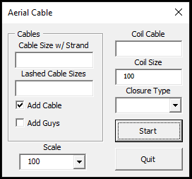

This program will add cable span blocks and add some units to the poles. It can also add cable lines, anchors, guys, coils, and/or closures.

When entering cable sizes, only use the number of fibers. If it is a CO(144) you only need to enter 144.

If you are placing a cable with strand, enter the cable size in the top left textbox. This will check Add Guys. You can change this manually if anchor and guy don’t need to be placed.

If you are lashing one or more cables to an existing strand, enter the cable sizes separated by a space. If only one cable, don’t put a space in the textbox.

If you don’t want to place lines between poles, uncheck Add Cable. If you don’t want to place anchors and guys, uncheck Add Guys.

Enter the cable size that will be coiled if there is a closure needed. It will auto fill when you enter the cable sizes on the left, but change the size if incorrect.

The default Coil Size is 100. Change this if necessary.

Select the Closure Type for the combobox or enter another if not listed.

Once you click Start, the form will hide and you will be prompted to select the pole to start placing cable. Next you will be prompted for the pole to place the cable. Then it will ask if you need a closure. If you enter anything that starts with the letter y, it will place a coil and closure at this pole.

It will continue to ask you for the next pole and if it needs a closure until you stop clicking on poles.

